SPRINT 1 BURNDOWN CHART

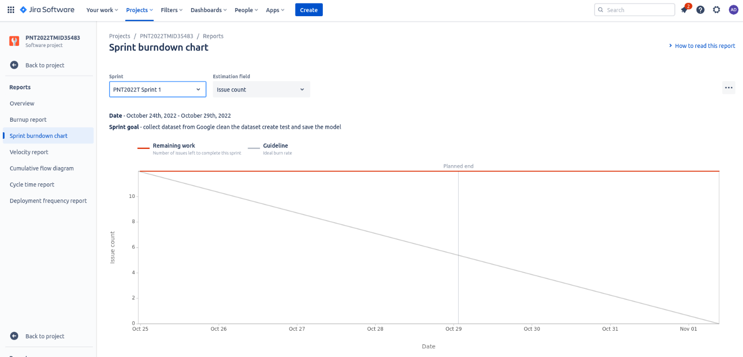

SPRINT 2 BURNDOWN CHART

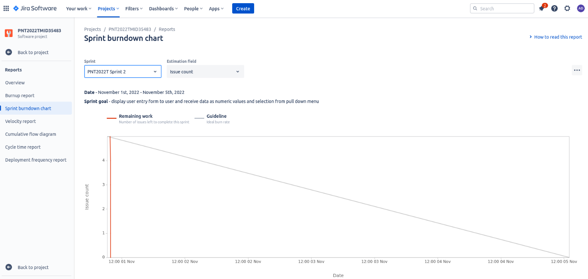

SPRINT 3 BURNDOWN CHART

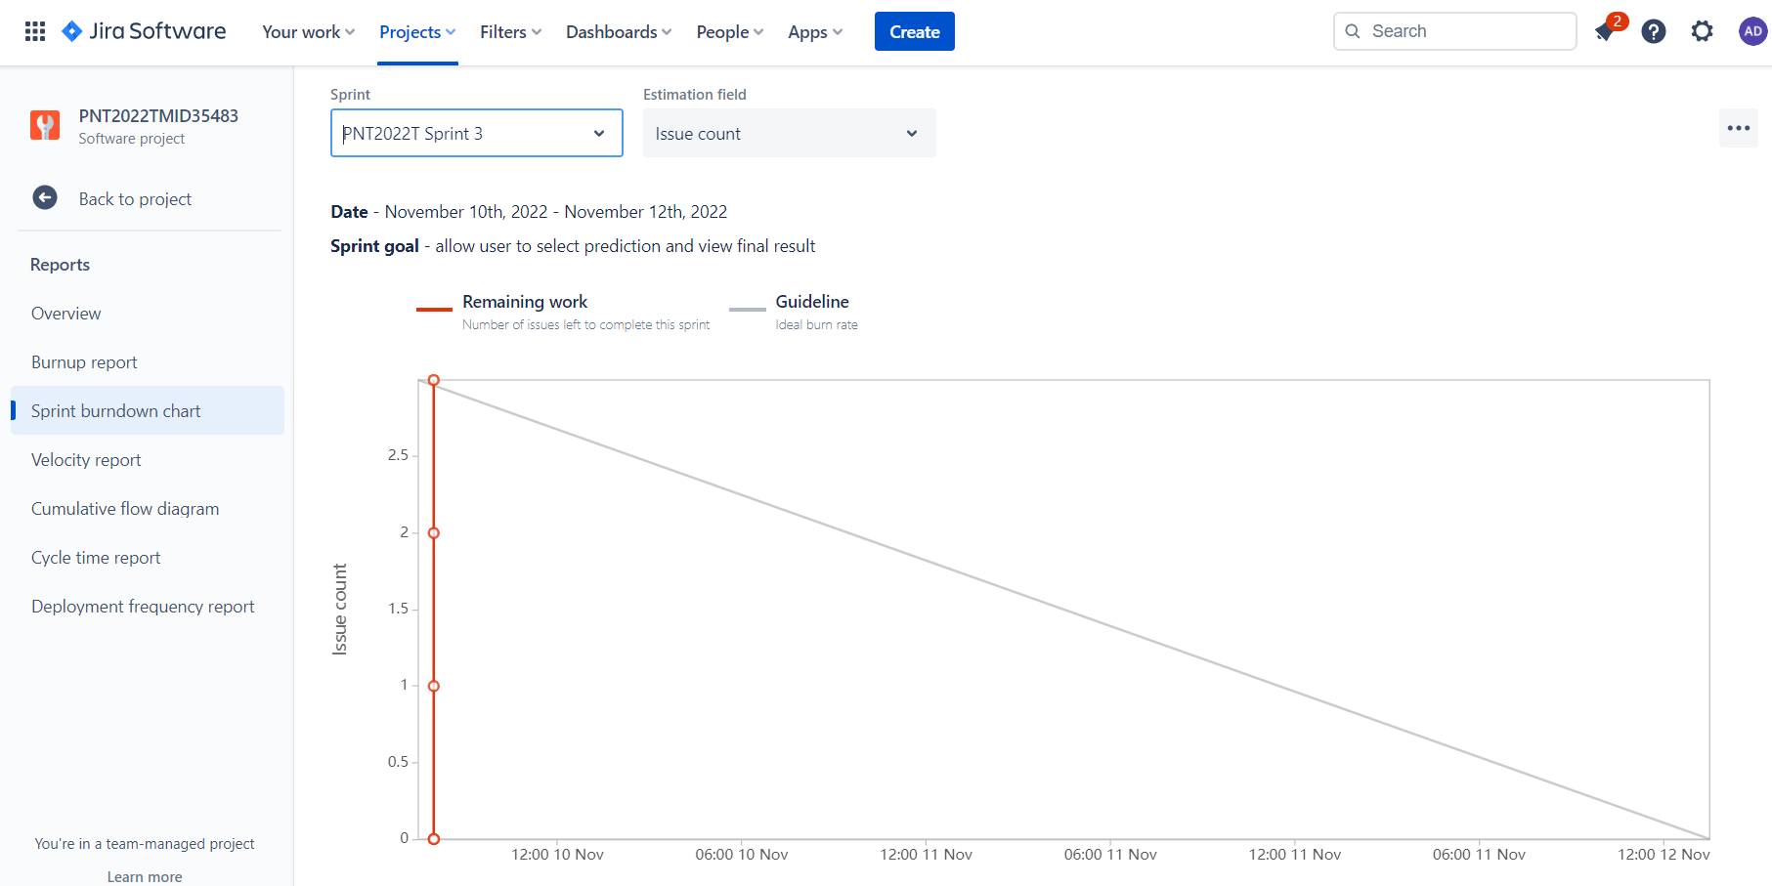

SPRINT 4 BURNDOWN CHART

